Ziptrrip Tech questions

Challenge 1: Answer the following five questions

Question 1.
Given that you are using JavaScript.
Write a function that takes n as input.
And prints the following pattern.

1
21
321
4321
...
nnnnn(n times)

Note:
Make sure the answer runs. Also, write this in different ways to achieve the same output.

Question 2.
Given that you are using JavaScript.
Write some code to reverse characters in a string
input:
"Bhaskara"

output:
"araksahB"

Note:
Make sure the answer runs. Also, write this in different ways to achieve the same output.

Question 3.
Given that you are using JavaScript.
Write some code to remove duplicates in an array and output the unique values.
Input:
[ 1, 2, 3, 6, 4, 3, 7, 4, 2, 6, 8, 2, 5, 9, 0, 1 ]

Output:
[ 1, 2, 3, 6, 4, 7, 8, 5, 9, 0 ]

Note:
Make sure the answer runs. Also, write this in different ways to achieve the same output.

Question 4.
Consider the following HTML

01 <div id=”container”>
02 <div class=”box”></div>
03
04 <div class=”box2”></div>
05 <div>
06 <div class=”box”></div>
07 </div>
08 </div>
09
10 <div class=”box”></div>

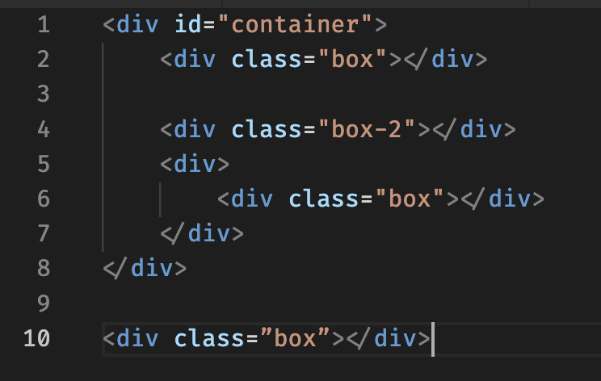

For each of the following selectors, write the line numbers of the elements that will be selected

.box

div .box

div.box

[class]

#container .box

#container > .box

Note:
Write the following for each selector
- Elements that will be selected (tell us line numbers).
- Explain why it will select those lines.
- Explain why it won't select other lines.

Question 5.
Consider the following HTML
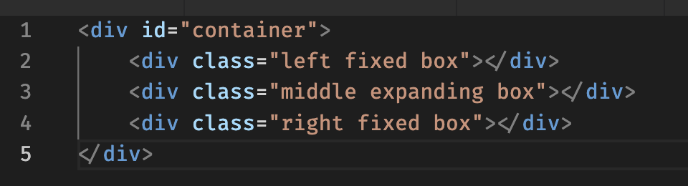

Following needs to be achieved using CSS:

- All 3 boxes inside the container need to be placed horizontally.
- First box should occupy a fixed width of 100px, and should be left aligned
<div class="left fixed box"></div> (line no 2)
- Last box hould occupy a fixed width of 100px, and should be right aligned
<div class="right fixed box"></div> (line no 2)
- The container can change widths, so the middle box should expand to the remaining available width between the left box and right box.
- The contents in the 3 boxes should not overlap.

Note:
Write CSS to achieve the above. Also, achieve this in more than one ways and share.

Challenge 2: Make a todo application

Frontend:
Implement a basic react application. Application has to be multiple page instead of SPA.
Make one page for todos list. Add the necessary features here. (refer to online todo applications for feature ideas)
Make second page for single todo item. This page should receive a query parameter of todo id and display the todo (plus any other information that you associate it with).

Backend:
Implement a nodejs app with expressjs.
Create CRUD apis for todos.
Save the data in a file or in a database. Either is fine.

To qualify:
- Checkin the code for the above problem in a git repository and share the repo link with us.
- Document the features and functionalities. Undocumented features will not be considered.
- Documentation has to be in .md files in the repository itself.

Challenge 1: Answers
Question 1:
Method 1 - Using Nested Loops

Code - function printPattern(n) {
for (let i = 1; i <= n; i++) {
let row = "";

for (let j = i; j >= 1; j--) {
row += j;
}

console.log(row);
}
}

printPattern(7);

Explanation - In this approach, the outer loop is used to generate each row of the pattern. The inner loop starts from the current row number and decreases until 1. The generated values are stored in a string and printed after each iteration.

Method 2 - Using Recursion

Code - function printRow(num) {
if (num === 0) return "";
return num + printRow(num - 1);
}

function printPattern(n, current = 1) {
if (current > n) return;

console.log(printRow(current));
printPattern(n, current + 1);
}

printPattern(5);

Explanation - This solution uses recursion to generate each row. The function repeatedly calls itself until it reaches the base condition. The pattern is formed while returning from the recursive calls.

Method 3 - Using Array.form()

Code - function printPattern(n) {
for (let i = 1; i <= n; i++) {
let row = Array.from(
{ length: i },
(_, index) => i - index
).join("");

console.log(row);
}
}

printPattern(5);

Explanation - In this approach, JavaScript's Array.from() method is used to create an array containing numbers in decreasing order. The array elements are joined together to form the required pattern.

Question 2:
Method 1 – Using split(), reverse(), join()

Code - function reverseString(str) {
return str.split("").reverse().join("");
}
console.log(reverseString("Bhaskara"));

Explanation - This is the simplest and most commonly used approach. The string is first converted into an array using split(), then reversed using reverse(), and finally converted back to a string using join().

Method 2 – Using a For Loop

Code - function reverseString(str) {
let reversed = "";
for (let i = str.length - 1; i >= 0; i--) {
reversed += str[i];
}
return reversed;
}
console.log(reverseString("Bhaskara"));

Explanation - In this method, the string is traversed from the last character to the first character. Each character is appended to a new string, resulting in the reversed string.

Method 3 – Using Recursion

Code - function reverseString(str) {
if (str === "") {
return "";
}
return reverseString(str.substr(1)) + str.charAt(0);
}
console.log(reverseString("Bhaskara"));

Explanation - This approach uses recursion. The function repeatedly removes the first character and calls itself on the remaining string. While returning from the recursive calls, the characters are added in reverse order.

Method 4 – Using reduce()

Code - function reverseString(str) {
return str.split("").reduce((rev, char) => char + rev, "");
}
console.log(reverseString("Bhaskara"));

Explanation - This solution uses the reduce() function to build the reversed string by placing each character before the accumulated result.

Question 3:
Method 1 – Using Set

Code - const arr = [1, 2, 3, 6, 4, 3, 7, 4, 2, 6, 8, 2, 5, 9, 0, 1];
const uniqueArray = [...new Set(arr)];
console.log(uniqueArray);

Explanation - A Set stores only unique values. By converting the array into a Set and then back into an array using the spread operator, all duplicate elements are removed automatically.

Method 2 – Using filter()

Code - const arr = [1, 2, 3, 6, 4, 3, 7, 4, 2, 6, 8, 2, 5, 9, 0, 1];
const uniqueArray = arr.filter((item, index) => arr.indexOf(item) === index);
console.log(uniqueArray);

Explanation - The filter() method checks whether the current element appears for the first time in the array. If the current index matches the first occurrence index, the element is kept; otherwise, it is removed.

Method 3 – Using For Loop

Code - const arr = [1, 2, 3, 6, 4, 3, 7, 4, 2, 6, 8, 2, 5, 9, 0, 1];
const uniqueArray = [];
for (let i = 0; i < arr.length; i++) {
if (!uniqueArray.includes(arr[i])) {
uniqueArray.push(arr[i]);
}
}
console.log(uniqueArray);

Explanation - In this approach, each element is checked before adding it to the new array. If the element is not already present, it is inserted into the unique array.

Method 4 – Using reduce()

Code - const arr = [1, 2, 3, 6, 4, 3, 7, 4, 2, 6, 8, 2, 5, 9, 0, 1];
const uniqueArray = arr.reduce((result, current) => {
if (!result.includes(current)) {
result.push(current);
}
return result;
}, []);
console.log(uniqueArray);

Explanation - The reduce() method iterates through the array and builds a new array containing only unique elements. Before inserting a value, it checks whether that value already exists in the result array.

Question 4:
Selector 1 - .box
Explanation – It selects line number 02, 06, 10 and not any other because the selector .box selects all elements having the class name box.
- Line 01 has id="container" but no class "box".
- Line 04 has class "box2", not "box".
- Line 05 is a div without class "box".

